MINISTRY OF EDUCATION AND TRAINING

FPT UNIVERSITY
Capstone Project Document
Sportswear E-Commerce Website

Group 3
Group Members | Nguyễn Minh Quang – SE181573  Trần Văn Quyết – SE181574  Nguyễn Phước Sanh – SE181668
Supervisor | Nguyễn Xuân Huy
Ext Supervisor
Capstone Project code

Ho Chi Minh, 07/17/2026
Table of Contents
Acknowledgement 3
Definition and Acronyms 3
I. Project Introduction 4
1. Overview 4
2. Product Background 4
3. Existing Systems 4
4. Business Opportunity 4
5. Software Product Vision 5
6. Project Scope & Limitations 5
II. Project Management Plan 7
1. Overview 7
2. Management Approach 8
3. Project Deliverables 9
4. Responsibility Assignments 9
6. Configuration Management 9
III. Software Requirement Specification 10
1. Product Overview 10
2. User Requirements 11
3. Functional Requirements 12
4. Non-Functional Requirements 13
5. Requirement Appendix 14
IV. Software Design Description 15
1. System Design 15
2. Database Design 16
3. Detailed Design 18
1. Scope of Testing 31
2. Test Strategy 31
4. Test Cases 32
VI. Release Package & User Guides 33
1. Deliverable Package 33
3. User Manual 34

Acknowledgement
We sincerely appreciate the guidance and support received from our supervisors and faculty members throughout the development of this project. Their expertise and constructive feedback have been invaluable in shaping the direction and quality of our Sportswear E-Commerce Website. We also extend our gratitude to all team members for their dedication and collaboration during this 10-week development period.

Definition and Acronyms
The following table lists the key definitions and acronyms referenced throughout this document:
- SRS: Software Requirement Specification
- SAD: Software Architecture Design
- ERD: Entity-Relationship Diagram
- ORM: Object-Relational Mapping (JPA/Hibernate)
- JWT: JSON Web Token used for stateless authentication
- NLP: Natural Language Processing (used in AI Chatbot)
- FCM: Firebase Cloud Messaging for push notifications
Acronym | Definition
DTO | Data Transfer Object
AWS | Amazon Web Services
BA | Business Analysis
BR | Business Rule
ERD | Entity Relationship Diagram
GUI | Graphical User Interface
PM | Project Manager
SDD | Software Design Description
SPMP | Software Project Management Plan
SRS | Software Requirement Specification
UAT | User Acceptance Test
UC | Use Case
API | Application Program Interface

I. Project Introduction
This chapter presents an overview of the Sportswear E-Commerce Website project, covering its background, objectives, scope, and the business context that motivated its development.

1. Overview

1.1 Project Information
Project Name: Sportswear E-Commerce Website
Project Code: SWP391_SPORTSWEAR_G1
This initiative focuses on building a dedicated web-based platform for retailing sportswear items online. The application integrates standard e-commerce functions—such as product catalogs, cart management, and payment processing—with advanced capabilities including AI-powered product categorization and a conversational chatbot for personalized product suggestions.

1.2 Project Team
The project team consists of members responsible for frontend development (ReactJS), mobile application development (Flutter), backend development (Spring Boot microservices), database design (PostgreSQL), and AI integration. Key stakeholders include the course instructor serving as the project supervisor and the development team members who act as both developers and testers.

2. Product Background
The surge in online shopping has created a growing preference among consumers to purchase sportswear through digital channels rather than visiting brick-and-mortar stores. Nevertheless, numerous small and medium-sized sportswear retailers still lack fully-featured e-commerce platforms, often depending on social media for sales. This reliance results in inadequate order management, minimal customer support automation, and overall operational inefficiency.
Modern customers demand seamless product discovery, secure online transactions, real-time order tracking, and access to trustworthy product evaluations before committing to a purchase. Simultaneously, store operators need robust tools to efficiently oversee product inventories, process orders, and address customer feedback.
These gaps in the market clearly indicate the need for a purpose-built e-commerce solution designed for sportswear retail, enhanced with intelligent customer engagement features.

3. Existing Systems
Several existing platforms serve as reference points for this project. Major e-commerce platforms such as Shopee and Lazada provide general-purpose online shopping experiences but lack specialization for sportswear. Dedicated sports retailers like Nike.com and Adidas.com offer tailored shopping experiences but operate at enterprise scale with proprietary technology stacks. These systems informed our design decisions, particularly in areas of product filtering, checkout workflows, and user review mechanisms.

4. Business Opportunity
The sportswear market continues to expand significantly, driven by increasing health awareness and active lifestyle trends. Many small retailers lack the technical capability to establish their own e-commerce presence, creating an opportunity for a specialized platform that addresses their unique needs.
Unlike general-purpose marketplaces, this system offers domain-specific features including AI-based product classification tailored to sportswear categories and an intelligent chatbot capable of recommending products based on customer preferences and sporting activities. These differentiators position the platform as an attractive solution for retailers seeking to modernize their sales channels without substantial technical investment.

5. Software Product Vision
The core objectives driving this system's development are:
- To deliver an intuitive and user-friendly platform enabling customers to browse and purchase sportswear products online with ease.
- To facilitate secure digital payment processing and comprehensive order tracking capabilities.
- To empower customers to assess product quality through an integrated review and rating mechanism.
- To leverage chatbot technology for automated product recommendations and customer inquiry resolution.
- To architect a maintainable and scalable software system grounded in established software engineering principles.
- To practically demonstrate the application of architectural design methodologies studied throughout the course.

6. Project Scope & Limitations
Included Features:
The project concentrates on the following primary functional domains:
- Purchase management: encompassing product browsing, shopping cart operations, checkout processing, and payment integration.
- Chatbot: providing automated customer assistance and intelligent product recommendations.
- Order status management: enabling order progress tracking and status notifications.
- Product review management: supporting product ratings and written reviews from verified purchasers.
- Administrative management: facilitating product catalog and order management for store operators.
Excluded Features:
To maintain a manageable scope within the 10-week academic timeline, the following capabilities are deliberately excluded:
- Advanced multi-region active-active database clustering and real-time physical IoT logistics tracking.
- Sophisticated warehouse and inventory management systems.
- Real-time integration with third-party logistics and shipping providers.
- Advanced business intelligence analytics and collaborative filtering recommendation engines.

II. Project Management Plan
This chapter outlines the project management approach, development methodology, objectives, and organizational structure employed throughout the Sportswear E-Commerce Website project.

1. Overview

1.1 Scope & Estimation
Function Complexity and Effort Estimation Table:
- Product Catalog & Search (UC01-UC03): Medium Complexity | Effort: 5 Man-Days
- User Authentication & Profile (UC04, UC07-UC10): Simple Complexity | Effort: 3 Man-Days
- Shopping Cart Management (UC11-UC13): Simple Complexity | Effort: 4 Man-Days
- Checkout & Payment Gateway Integration (UC16-UC20): Complex Complexity | Effort: 8 Man-Days
- Order Tracking & Management (UC15, UC21, UC30-UC31): Medium Complexity | Effort: 6 Man-Days
- Product Review & Rating (UC06, UC14, UC22): Simple Complexity | Effort: 3 Man-Days
- AI Chatbot Integration (UC05): Complex Complexity | Effort: 8 Man-Days
- AI Product Classification (UC26-UC29): Complex Complexity | Effort: 7 Man-Days
- Administrative Dashboard & Reports (UC23-UC24): Medium Complexity | Effort: 6 Man-Days
Total Estimated Effort: 50 Man-Days across the 5-member project team.

1.2 Project Objectives
Project Target Metrics & Effort Distribution:
- Quality Objectives: Achieve at least 85% automated unit test coverage on core backend domain services. Zero critical security vulnerabilities or severity-1 bugs upon final release.
- Time Objectives: Complete all 5 planned iterations strictly within the allocated 10-week course schedule without schedule slippage.
- Effort Allocation: Requirements & Analysis (15%), Architecture & UI/UX Design (25%), Backend & Frontend Coding (40%), Testing & Bug Fixing (15%), Project Management (5%).

1.3 Project Risks
Project Risk Register and Mitigation Strategy:
- Risk 1 (Technical - Complex): AI Classification Service accuracy instability or high latency. Mitigation: Implement asynchronous background processing, fallback to rule-based category defaults, and provide an admin manual override interface.
- Risk 2 (Technical - Medium): VNPay/Momo Sandbox API downtime or callback failures during checkout testing. Mitigation: Build a simulated local payment provider toggle for development environments and implement idempotent webhook retry logic.
- Risk 3 (Infrastructure - Medium): Redis cache synchronization lag causing outdated product pricing or stock display. Mitigation: Enforce explicit cache eviction triggers on every inventory update transaction and configure appropriate Time-To-Live (TTL) policies.
- Risk 4 (Schedule - Medium): Scope creep due to complex chatbot NLP adjustments. Mitigation: Strictly time-box chatbot feature iterations and adhere to the predefined MVP scope agreed upon with the supervisor.

2. Management Approach
The project adopted an Agile development methodology to accommodate the iterative nature of the development process and the evolving requirements throughout the project lifecycle.

2.1 Project Process
The team employed the Agile development model for this project. Development was organized into multiple short iterations, each spanning approximately two weeks, with each cycle producing a set of working features. This methodology proved well-suited to the project as requirements had a degree of flexibility and could be refined based on ongoing feedback and technical feasibility assessments.
The Agile approach also enabled the team to prioritize essential functionalities—such as the purchase workflow and order management—before proceeding to more sophisticated features like chatbot integration.
The development lifecycle encompasses the following phases:
- Planning: establishing project scope, identifying core workflows, and selecting the technology stack.
- Analysis: gathering functional and non-functional requirements, defining actors and use cases.
- Design: creating the system architecture, database schema, and UML models.
- Implementation: developing frontend and backend modules in accordance with the design specifications.
- Testing: conducting unit tests, API validation, and integration testing.
- Deployment: containerizing the application using Docker for local deployment.
- Maintenance: addressing defects and enhancing performance and usability.
Each iteration progresses through these phases, incrementally building toward a complete system.

2.2 Quality Management
Quality Management and Assurance Strategy:
- Code Quality & Standards: All team members strictly adhere to layered architectural boundaries and naming conventions. Pull requests require at least one peer review before merging into the main branch.
- Static Analysis: Integrated SonarQube linting rules into our local IDEs to proactively identify code smells, unused variables, and potential null pointer exceptions.
- Continuous Testing: Automated JUnit 5 tests execute on critical service methods (cart pricing calculation, stock validation, and order lifecycle transitions). Postman API suites validate end-to-end REST endpoint contracts.

2.3 Training Plan
Project Team Training and Upskilling Plan:
- Spring Boot & Clean Architecture (Week 1): 4-hour internal workshop conducted by the Backend Lead focusing on JPA/Hibernate entity mappings, DTO projections, and Spring Security JWT filter configurations.
- ReactJS & State Management (Week 1-2): Targeted self-paced tutorials and pair programming sessions on custom hooks, Redux/Context API, and Axios interceptors.
- AI Integration & Prompt Engineering (Week 3): Workshop on interacting with external AI service APIs for automated product categorization and chatbot response formatting.
- Docker Containerization (Week 4): Practical walkthrough on creating optimized Dockerfiles and writing multi-service docker-compose configurations.

3. Project Deliverables
Project Deliverables Inventory:
- D01 - Software Requirement Specification (SRS): External deliverable covering complete functional/non-functional requirements and use case diagrams (Report 3).
- D02 - Software Architecture & Detailed Design (SAD): External deliverable encompassing system architecture, ERD, activity, and sequence diagrams (Report 4 & Report 7).
- D03 - Source Code Repository: Internal & external deliverable containing fully commented Spring Boot backend and ReactJS frontend codebase hosted on GitHub.
- D04 - Test Plan & Execution Report: External deliverable detailing test cases, execution metrics, and bug tracking history (Report 5).
- D05 - Release Package & Docker Environment: External deliverable consisting of containerized deployment files, SQL seed scripts, and installation guides (Report 6 & Report 7).

4. Responsibility Assignments
RACI Responsibility Assignment Matrix:
- Project Management & Architecture Design: Backend Lead (Accountable/Responsible), All Team Members (Consulted/Informed).
- Frontend UI/UX Implementation (ReactJS): Frontend Lead (Accountable/Responsible), Backend Lead (Consulted).
- Backend Services & API Development (Spring Boot): Backend Lead (Accountable/Responsible), AI Engineer (Consulted).
- Database Schema & ORM Mapping: DB/DevOps Lead (Accountable/Responsible), Backend Lead (Consulted).
- AI Chatbot & Classification Integration: AI Engineer (Accountable/Responsible), Backend Lead (Consulted).
- QA & Automated/Manual Testing: All Team Members (Responsible for peer components), DB/DevOps Lead (Accountable for overall test execution).
5. Project Communications
Project Communication Protocol & Channels:
- Daily Standups: 15-minute sync conducted every morning via Discord voice chat to discuss progress, daily tasks, and technical blockers.
- Bi-Weekly Sprint Reviews: Formal meeting with the faculty supervisor every two weeks to demonstrate working iterations, review project reports, and receive feedback.
- Instant Messaging & Collaboration: Dedicated Discord guild and Zalo group chat organized by topical channels (#backend-dev, #frontend-ui, #database, #bugs-and-qa).
- Task & Backlog Tracking: GitHub Projects Kanban board utilized to assign user stories, track issue status (To Do, In Progress, Review, Done), and link commits to tasks.

6. Configuration Management

6.1 Document Management
Document Version Control & Storage:
All project reports, architectural models, and meeting minutes are stored centrally in a shared Google Drive workspace and mirrored on the repository Wiki. Documents follow semantic versioning (e.g., Report_v1.0_Draft, Report_v1.01_Final). Major structural revisions require formal team consensus during sprint reviews.

6.2 Source Code Management
Source Code Configuration Management (GitFlow Strategy):
- Branching Model: The repository maintains two protected branches: `main` (production-ready release artifacts) and `develop` (integration branch for current iteration features).
- Feature Branches: Developers branch off `develop` using the convention `feature/UCxx-feature-name` or `bugfix/issue-description`.
- Pull Request Policy: Direct commits to `main` or `develop` are strictly prohibited. All merges require a Pull Request with successful CI build verification and explicit approval from at least one peer reviewer.

6.3 Tools & Infrastructures
Programming Languages:
- Java (backend logic and API development)
- JavaScript/ReactJS (frontend user interface)
Frameworks and Libraries:
- Spring Boot for backend application development
- Spring Security for authentication and authorization mechanisms
- ReactJS for building the frontend user interface
- JPA/Hibernate for object-relational mapping and database access
Databases:
- PostgreSQL as the primary relational database management system
- Redis for caching session data and frequently accessed product information
Development and Deployment Tools:
- Git for distributed version control
- Docker for application containerization
- Swagger/OpenAPI for interactive API documentation
- JUnit for automated backend unit testing
- Postman for manual and automated API testing

III. Software Requirement Specification
This chapter details the software requirements for the Sportswear E-Commerce Website, covering the product overview, user requirements with use case specifications, functional requirements, and non-functional quality attributes.

1. Product Overview
The Sportswear E-Commerce Website is a web-based retail platform engineered specifically for sportswear products. It delivers essential shopping capabilities including product catalog management, shopping cart functionality, secure online payment processing, and order lifecycle management. Beyond standard e-commerce features, the platform incorporates intelligent components: an AI-powered product classification module that automatically categorizes items, and a conversational chatbot that provides personalized product recommendations to enhance the customer shopping experience.
The system is realized as a multi-client platform utilizing ReactJS for web interfaces, Flutter for mobile applications, and Spring Boot for backend microservices, adhering to a Distributed Multi-Service (Microservice-oriented) architectural pattern.

2. User Requirements
The system identifies four primary actor categories:
1. Registered User - Has access to review submission, address management, order status monitoring, order history viewing, AI chatbot interaction, product searching, and purchase management.
2. Admin - Responsible for review/rating management, review responses, AI product classification, and order status updates.
3. Shipper - Authorized to update order delivery statuses.
4. Guest - Can interact with the AI chatbot, search for products, and initiate purchase workflows.
Use Case Diagram:
The following diagram illustrates the complete use case model for the Sport Swear Shop System, showing all actors and their associated use cases with include and extend relationships:
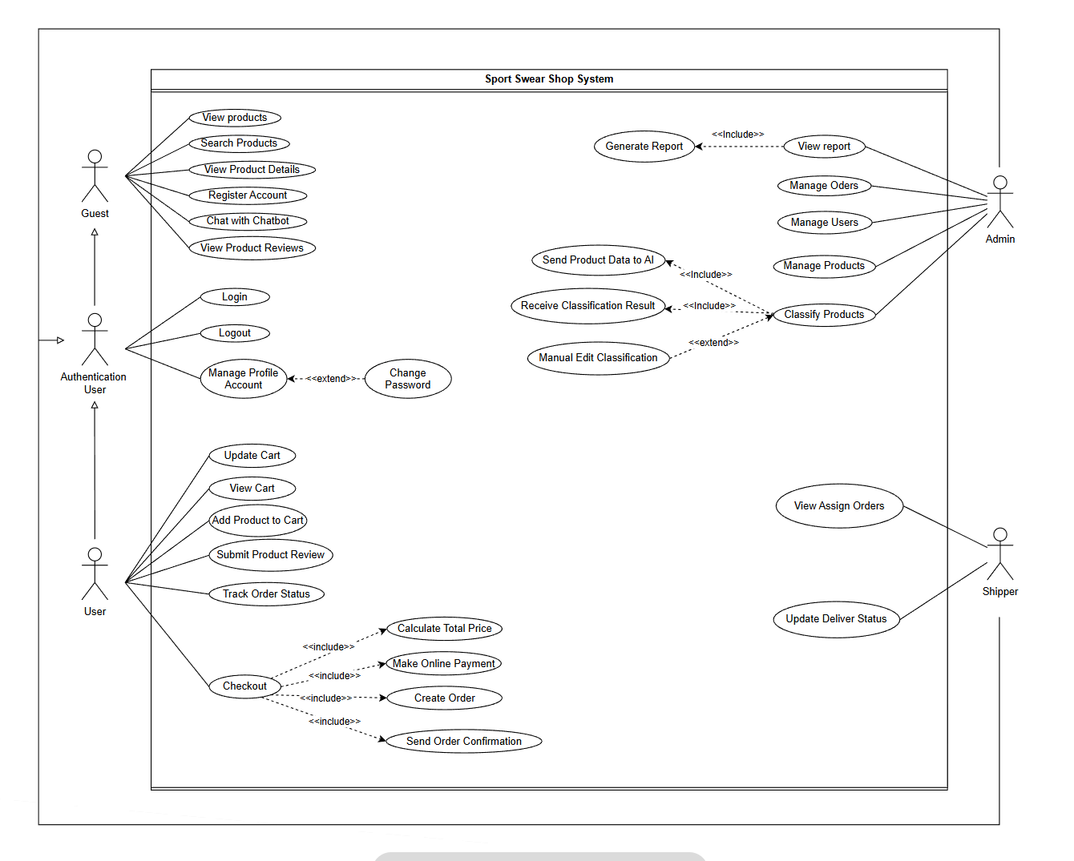
Figure: Use Case Diagram
Use Case Summary Table:
UC01 - View Products: Guest browses the available product catalog.
UC02 - Search Products: Guest performs product search by name, category, or keywords.
UC03 - View Product Details: Guest accesses comprehensive information about a specific product.
UC04 - Register Account: Guest creates a new account to become a registered user.
UC05 - Chat with Chatbot: Guest engages with the AI chatbot for product recommendations.
UC06 - View Product Reviews: Guest reads existing product reviews and ratings.
UC07 - Login: Authenticated user signs into the system.
UC08 - Logout: Authenticated user signs out of the system.
UC09 - Manage Profile: User modifies personal profile information.
UC10 - Change Password: User updates account password.
UC11-UC13 - Cart Operations: User manages shopping cart (add, view, update items).
UC14 - Submit Review: User writes and submits a product review with rating.
UC15 - Track Order: User monitors the current status of placed orders.
UC16-UC20 - Checkout Flow: User completes checkout, system calculates totals, processes payment, creates order, and sends confirmation.
UC21-UC24 - Admin Functions: Admin manages orders, users, products, and views reports.
UC26-UC29 - AI Classification: Admin triggers AI classification, system processes and returns results, admin can manually adjust.
UC30-UC31 - Shipper Functions: Shipper views assigned orders and updates delivery status.

3. Functional Requirements

3.1 System Functional Overview
The system's functional requirements encompass the following key capabilities:
- User account registration and secure authentication via JWT tokens.
- Product catalog display with comprehensive product detail pages.
- Advanced search and multi-criteria filtering for sportswear items.
- Shopping cart management including item addition, quantity modification, and removal.
- Checkout processing with simulated online payment through VNPay or Momo integration.
- Complete order lifecycle management from creation through fulfillment.
- Real-time order status tracking and notification delivery.
- Product rating and review submission for verified purchasers.
- Public access to aggregated product reviews and ratings.
- AI-powered chatbot for product suggestions and customer inquiry resolution.
- Administrative dashboard for product catalog, order, and user management.

3.2 Purchase Management Feature
The Purchase Management module enables end-to-end shopping transactions, providing seamless transition from browsing to confirmed payment:
- Function 1: Product Browsing & Filtering - Retrieves active product listings paginated and filtered by sport category, brand, size, and price range.
- Function 2: Shopping Cart Synchronization - Maintains user selected items, variant sizes, and quantities, validating real-time stock availability prior to checkout.
- Function 3: Checkout & Payment Processing - Calculates subtotal, shipping fees, applies discounts, initializes pending order records, and securely redirects users to VNPay/Momo payment gateways.
3.3 AI Chatbot & Customer Assistance Feature
The AI Chatbot module acts as a virtual shopping assistant accessible from any page within the website:
- Function 1: Natural Language Inquiry Processing - Analyzes customer messages regarding sportswear recommendations, sizing guides, or order policies.
- Function 2: Contextual Product Recommendations - Queries the product catalog based on identified sport categories and user preferences, returning clickable product cards inside the chat window.
…
3.4 Order Lifecycle & Status Tracking Feature
The Order Status Tracking module oversees order transitions across different fulfillment milestones:
- Function 1: Customer Order History & Tracking - Displays current order states (Pending, Paid, Shipped, Delivered, Cancelled) and detailed tracking timelines.
- Function 2: Shipper Delivery Updates - Authorized shippers can update delivery milestones, triggering automated status notifications to the customer.
3.5 Product Review & Administrative Classification Features
These modules support quality feedback and automated administrative catalog organization:
- Function 1: Verified Purchase Review Submission - Enables customers with delivered orders to submit 1-to-5 star ratings and written reviews, which are aggregated to compute average product scores.
- Function 2: AI-Powered Product Classification - Admin can submit new product images and descriptions to the AI service, which automatically detects product categories, genders, and associated sports, allowing admin verification before catalog publishing.
…

4. Non-Functional Requirements

4.1 External Interfaces
The system interfaces with the following external components:
- Payment Gateway APIs (VNPay/Momo) for processing online transactions.
- AI Service for product classification and chatbot intelligence.
- Email/Notification Service for order confirmations and status updates.
- Firebase Cloud Messaging (FCM) for push notifications.

4.2 Quality Attributes
The system is designed to satisfy the following quality attributes:
- Security: Token-based authentication using JWT with role-based access control ensuring authorized resource access.
- Performance: Redis caching layer to minimize database query overhead and improve response times for frequently accessed data.
- Scalability: Modular architectural design facilitating straightforward system expansion and potential migration to microservices.
- Reliability: Transactional integrity enforcement for critical operations including payment processing and order creation.
- Usability: Responsive user interface design ensuring optimal experience across various device form factors.
- Maintainability: Clear separation of concerns through layered architecture and modular component boundaries.

5. Requirement Appendix
This section documents supplementary business constraints, domain rules, and system-wide common requirements governing all transaction processing.

5.1 Business Rules
System Business Rules Table:
- BR-01 (Cart Inventory Check): When a customer initiates checkout, the system verifies available stock quantity. If stock is insufficient, the checkout is blocked and the user is notified immediately.
- BR-02 (Order State Transition): Orders must progress linearly from `Pending` -> `Paid` -> `Shipped` -> `Delivered`. Cancelled orders cannot be transitioned back to active states.
- BR-03 (Review Eligibility): Users can only submit a product review if they have a completed order containing that specific product with status `Delivered`. Only one review per purchased item is permitted.
- BR-04 (AI Classification Confidence): If the AI classification service returns a confidence score below 80% for a product categorization attempt, the system flags the item requiring mandatory manual admin review prior to publishing.

5.2 Common Requirements
System Common Requirements:
- CR-01 (Input Validation): All REST API endpoints must rigorously validate input payloads (null checks, string length restrictions, numeric bounds, and email/phone format regex patterns) and return standardized JSON error messages.
- CR-02 (Session Security): User JWT tokens expire after 24 hours of inactivity. Sensitive administrative actions require re-authentication.
- CR-03 (Audit Logging): Every order creation, payment state modification, and administrative product update must generate a timestamped audit log entry capturing the triggering user ID.

5.3 Application Messages List

5.4 Other Requirements…

IV. Software Design Description
This chapter presents the software design documentation for the Sportswear E-Commerce Website, including the system architecture, database design, and detailed design specifications with UML diagrams.

1. System Design

1.1 System Architecture
The system employs a Layered Architecture combined with a Distributed Multi-Service (Microservices) structure, providing clear separation of concerns, independent scaling, and deployment flexibility across specialized services.
System Architecture Diagram:
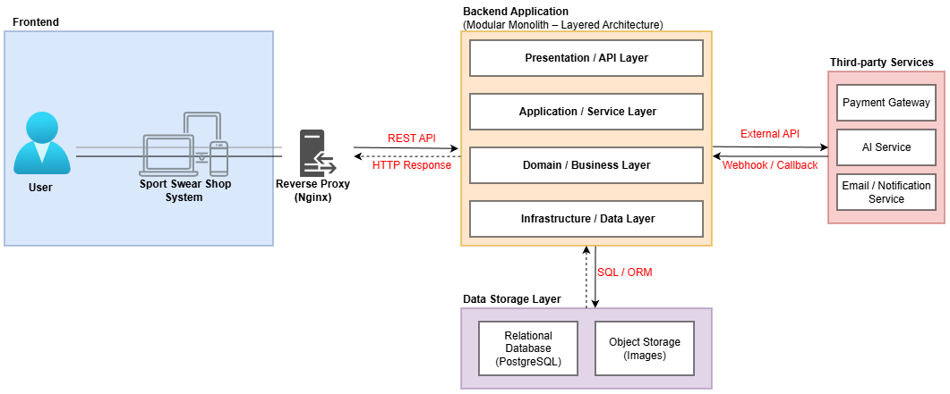
Figure: Architecture Diagram
Layered Architecture:
The backend application is structured into the following distinct layers:
- Presentation/API Layer: REST controllers responsible for handling incoming HTTP requests and formulating appropriate responses.
- Application/Service Layer: Data Transfer Objects (DTOs) and input validation logic ensuring data integrity.
- Domain/Business Layer: Service classes encapsulating core business rules and processing logic.
- Infrastructure/Data Access Layer: Repository classes interfacing with the database through JPA/Hibernate ORM.
Multi-Service (Microservices) Structure:
The backend is partitioned into 4 autonomous Spring Boot microservices aligned with business domains: Auth Service (Port 8081), Product Catalog Service (Port 8082), Order Fulfillment Service (Port 8083), and Support Chat Service (Port 8084), all orchestrated via Docker Compose with dedicated PostgreSQL schemas and Redis caching.
Deployment Diagram:
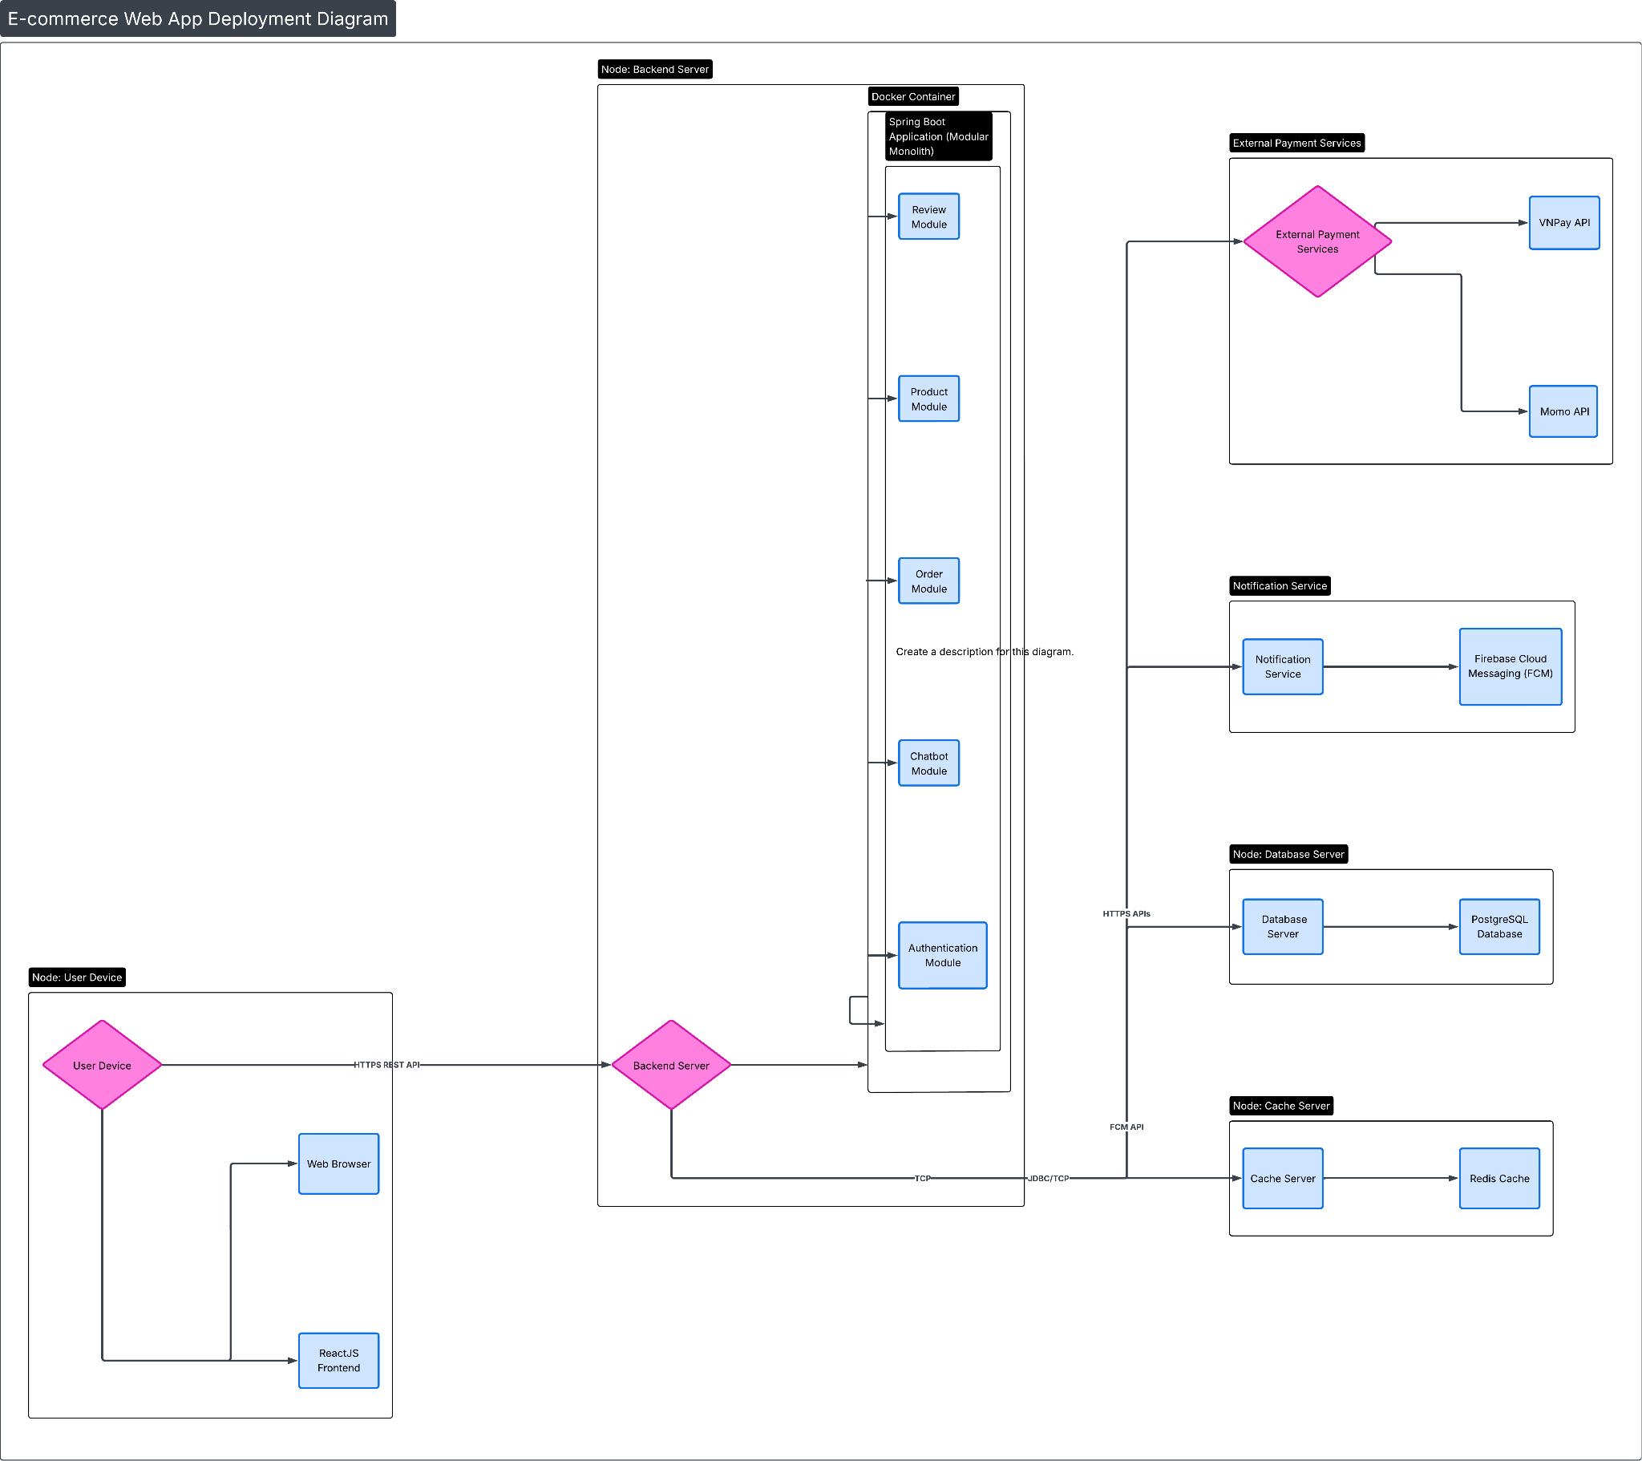
Figure: Deployment Diagram
The deployment architecture comprises a User Device running ReactJS Frontend communicating via HTTPS REST API to the Backend Server running Docker containerized Spring Boot Application alongside PostgreSQL and Redis instances.

1.2 Package Diagram
The system's package structure follows the standard Spring Boot convention organized by business domain modules. Each module contains sub-packages for controller, service, repository, dto, and entity classes ensuring clean separation of concerns.

2. Database Design
Conceptual Entity-Relationship Diagram:
The following ERD illustrates the core entities and their relationships within the system:
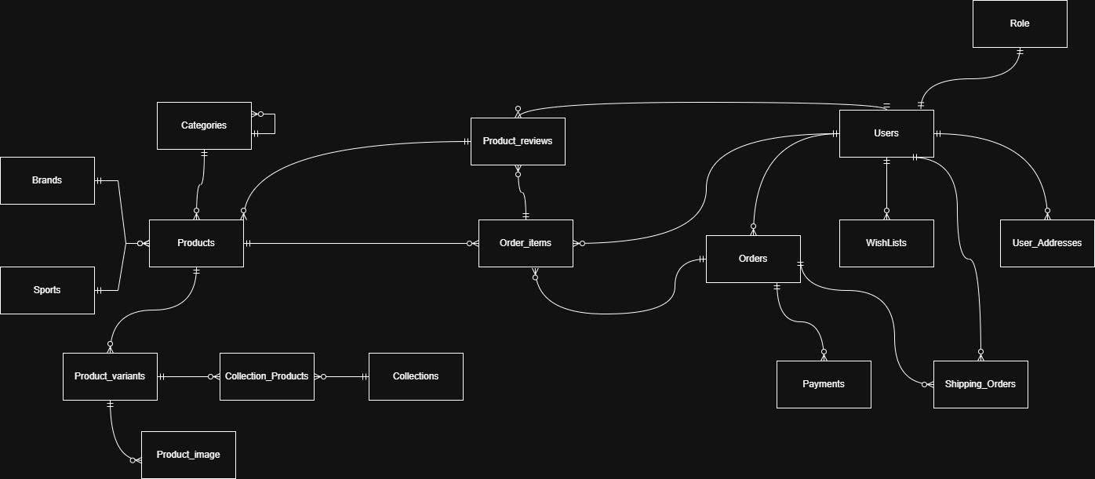
Figure: Conceptual ERD
Physical Database Design:
The complete database schema with all tables, columns, data types, and foreign key relationships is shown below:
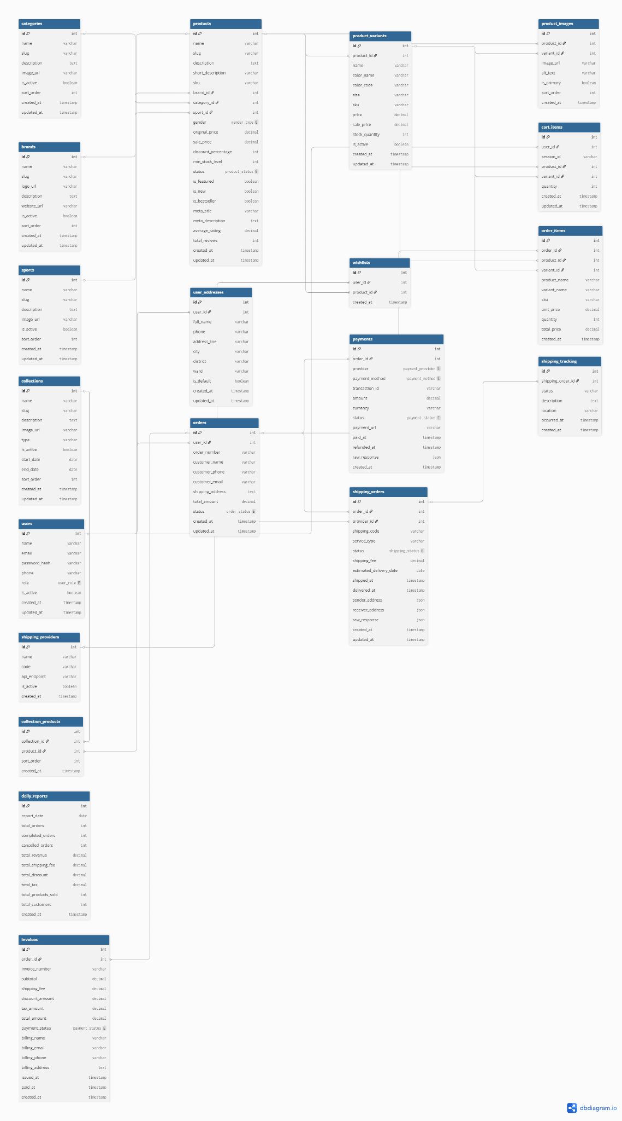
Figure: Database Diagram

3. Detailed Design
3.1 Detailed Feature Workflows & Sequence Diagrams
The detailed design for each major feature is documented below with activity diagrams illustrating the business workflow and sequence diagrams showing the technical interaction between system components.

3.1.1 Purchase Management
Activity Diagram - Purchase Flow:
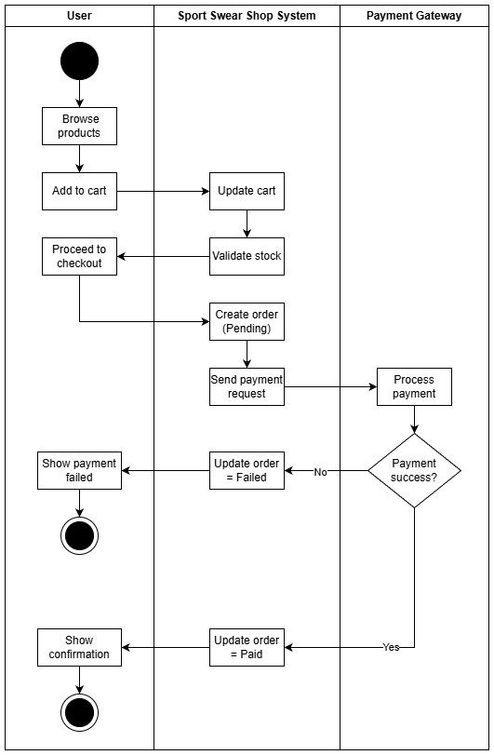
Figure: Activity Purchase
Sequence Diagram - Purchase Management:
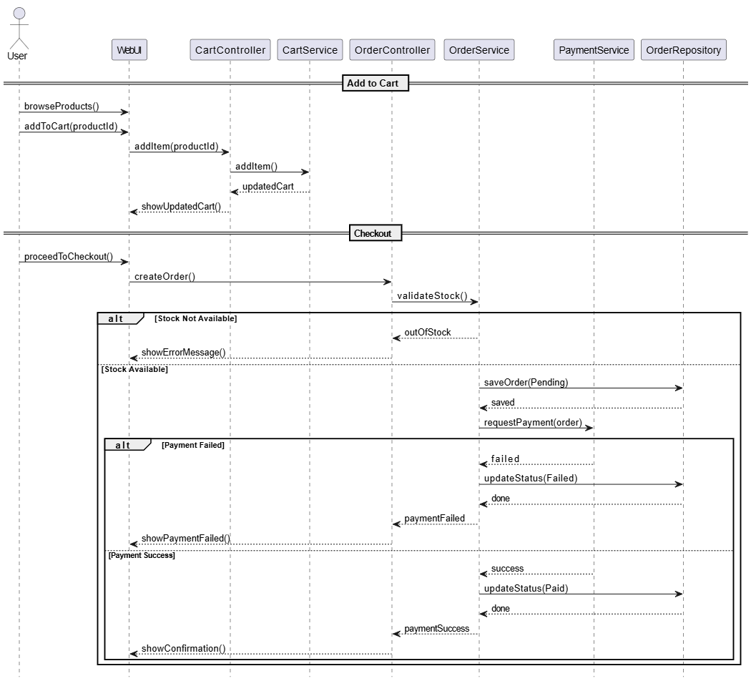
Figure: Sequence Purchase

3.1.2 Chatbot AI
Activity Diagram - Chatbot Interaction:
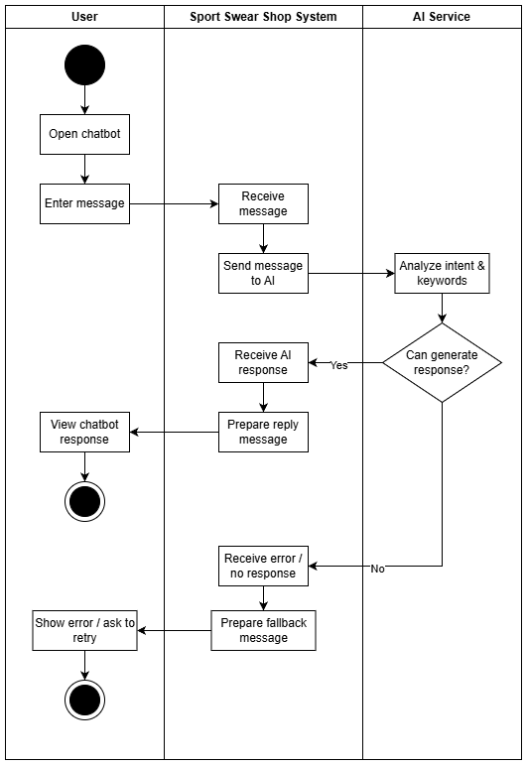
Figure: Activity Chatbot
Sequence Diagram - Chatbot AI:
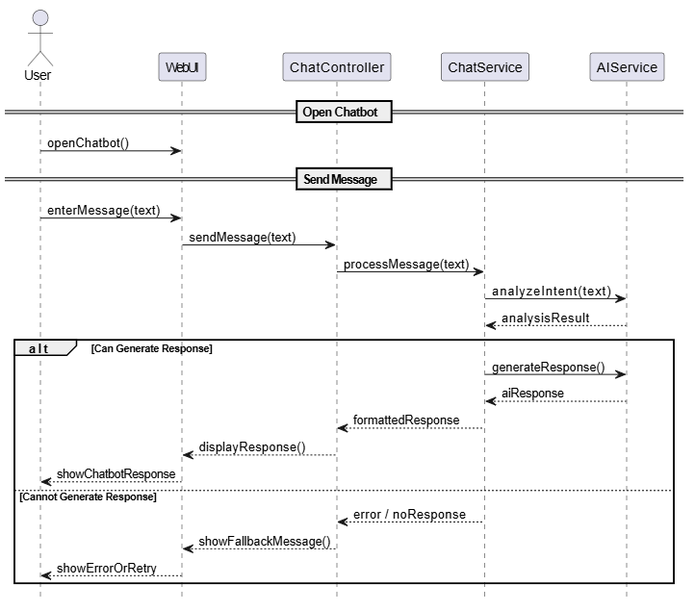
Figure: Sequence Chatbot

3.1.3 Order Status Tracking
Activity Diagram - Order Tracking:
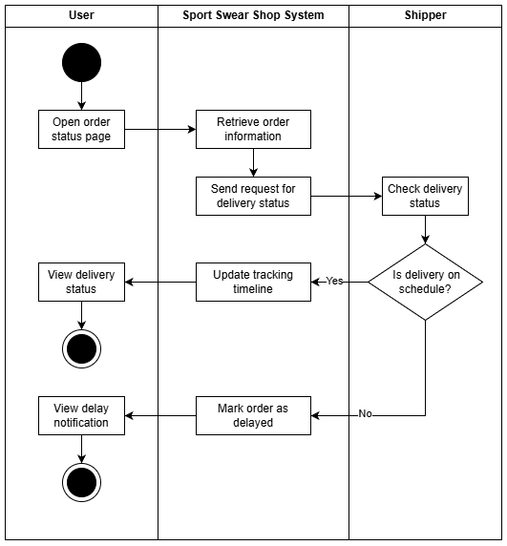
Figure: Activity Order
Sequence Diagram - Order Status:
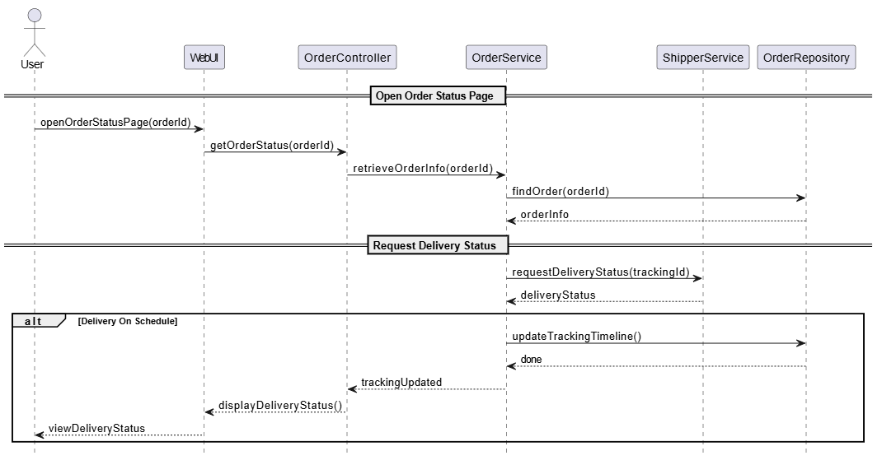
Figure: Sequence Order

3.1.4 Product Review
Activity Diagram - Product Review:
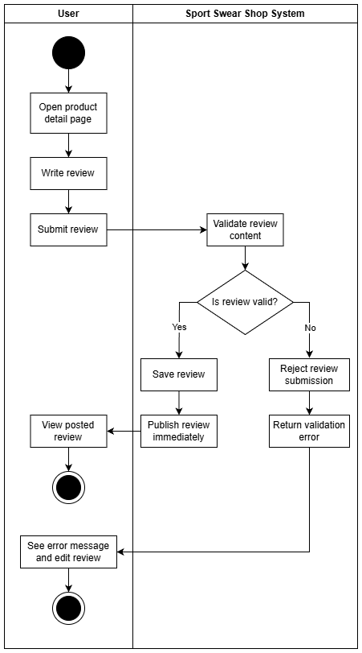
Figure: Activity Review
Sequence Diagram - Product Review:
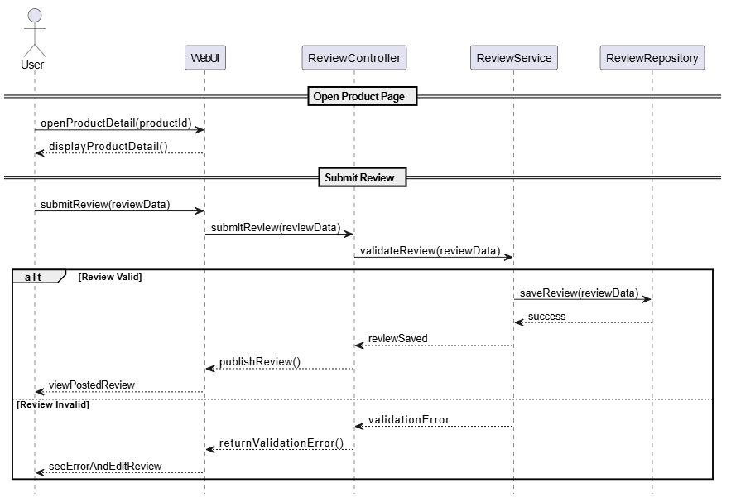
Figure: Sequence Review

3.1.5 Reports and Statistics
Activity Diagram - Reports:
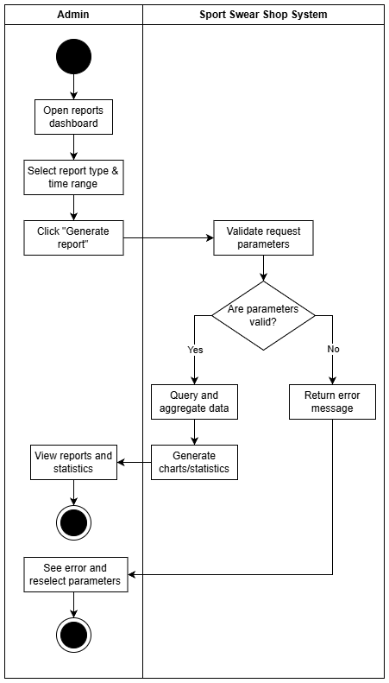
Figure: Activity Reports
Sequence Diagram - Reports & Statistics:
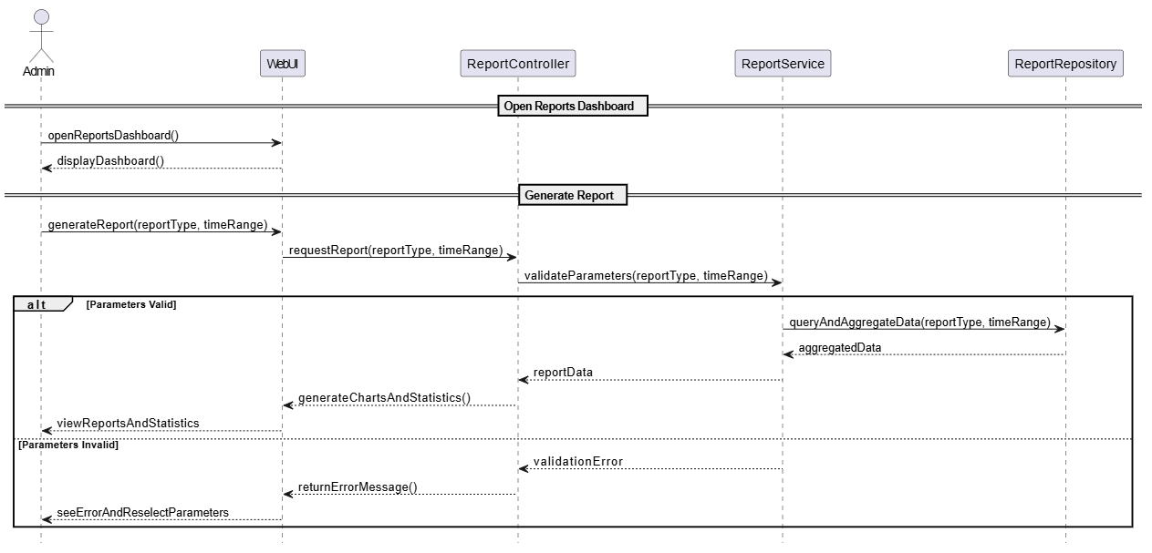
Figure: Sequence Reports

3.1.6 AI Product Classification
Activity Diagram - AI Classification:
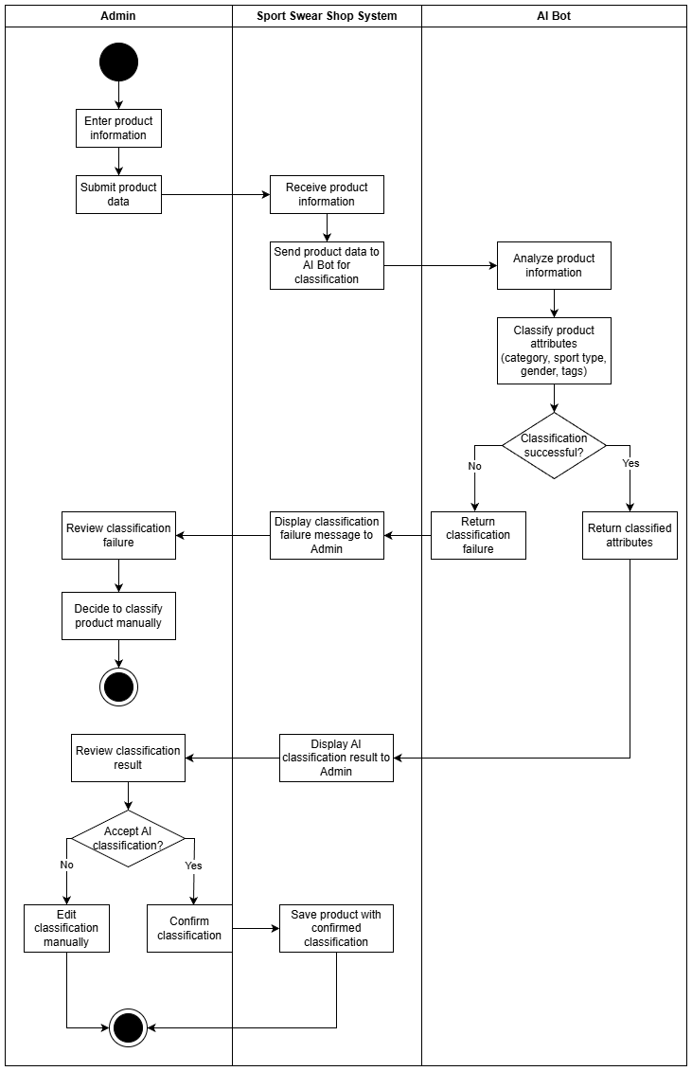
Figure: Activity AI Classification
Sequence Diagram - AI Product Classification:
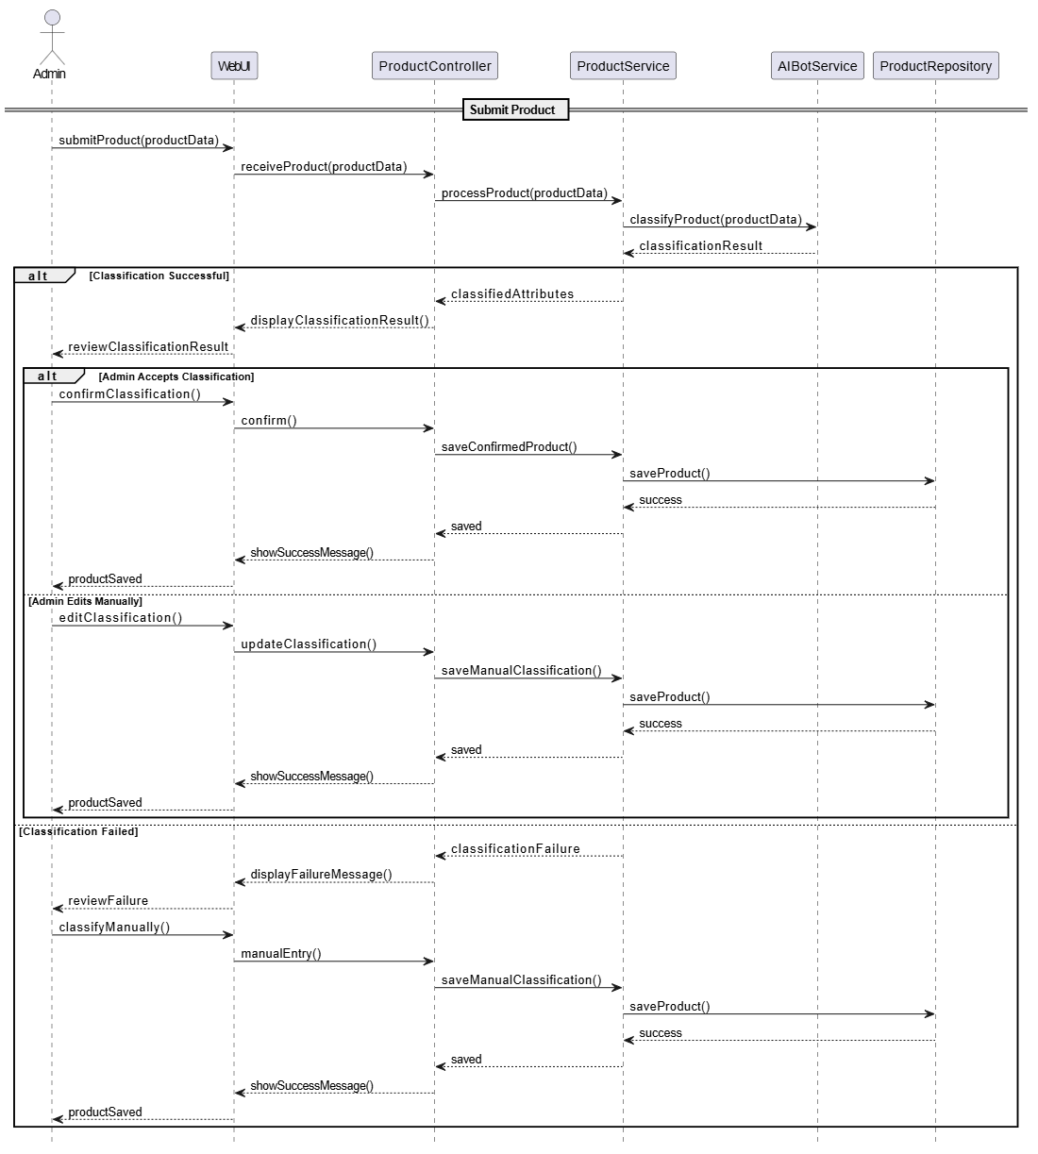
Figure: Sequence AI

3.1.1 Class Diagram
The domain entity models and class structures have been established across our domain modules (Product, Order, Review, User/Authentication).

3.1.7 Domain Component Interaction Summary
Please refer to the detailed sequence diagrams documented in section 3.1.1 through 3.1.6 above for complete interaction specifications.

3.1.3 …

…

V. Software Testing Documentation
This chapter documents the software testing approach, strategy, scope, roles, milestones, and execution results for the Sportswear E-Commerce Website.

1. Scope of Testing
Target of Test & Scope Definition:
- In-Scope Features: Complete functional validation of User Registration/Authentication, Product Browsing/Filtering, Shopping Cart operations, Checkout workflow (including mock payment callbacks), Order Lifecycle tracking, Review submission, AI Chatbot responsiveness, and Admin AI Product Classification.
- In-Scope Non-Functional Requirements: REST API performance under normal concurrency (response times < 500ms), Redis caching verification, and role-based security access control.
- Out-of-Scope: Third-party real-world banking network load penetration testing and physical shipping provider API stress testing.
Describe the stages/levels of testing that would be applied to your project - Unit, Integration, or System test. Each includes the in-charge, inputs/time, focuses, acceptance criteria.
List any constraints or assumptions made during the development of this document that may impact the design, development or implementation of testing]

2. Test Strategy
Overview of Testing Strategy & Types:
Our testing strategy incorporates a multi-level verification framework combining automated developer testing with structured quality assurance workflows.

2.1 Testing Types
Applied Testing Types & Specifications:
- Unit Testing: Objective is to verify individual business logic methods in service classes. Technique: White-box testing using JUnit 5 and Mockito. Completion Criteria: 85% line coverage on service layer without assertion failures.
- API / Integration Testing: Objective is to validate HTTP request/response contracts, data serialization, and database persistence. Technique: Black-box and gray-box testing using Postman automated collections. Completion Criteria: 100% pass rate on core transaction endpoints (Cart, Order, Auth).
- System / UI Functional Testing: Objective is to verify end-to-end user workflows across the ReactJS frontend and backend server. Technique: Manual exploration and guided scenario execution. Completion Criteria: All critical path user journeys complete without UI freezes or unhandled exceptions.

2.2 Test Levels
Executed Testing Levels:
- Component / Unit Level: Performed during coding iterations by developers focusing on isolated backend calculation and validation algorithms.
- Integration Level: Performed during iteration builds focusing on controller-service-repository interactions and Redis cache synchronization.
- System Level: Performed prior to iteration releases verifying unified frontend-backend functionality and external gateway mocks.

2.3 Supporting Tools
Test Supporting Tools & Infrastructure:
- JUnit 5 & Mockito: Automated Java unit testing framework and mocking library.
- Postman: API endpoint verification, environment variable injection, and automated Newman test runs.
- Swagger UI / OpenAPI: Live API contract verification and parameter testing directly from browser.
- pgAdmin & Redis CLI: Database inspection tools to verify physical persistence and cache invalidation during tests.
3. Test Plan

3.1 Human Resources
Testing Roles and Responsibility Matrix:
- Backend Lead & Developers: Responsible for writing and executing unit tests (JUnit) and maintaining API test suites.
- Frontend Lead: Responsible for UI component testing and cross-browser responsiveness validation.
- DB/DevOps Lead: Responsible for database integrity testing, transaction rollback verification, and test environment containerization.
- All Team Members: Participate in exploratory system testing and bug logging prior to sprint reviews.

3.2 Test Environment
Test Environment Infrastructure:
Testing is conducted across local developer workstation environments equipped with Docker Desktop running identical containerized instances of PostgreSQL 15 and Redis 7, ensuring consistency between test execution and staging deployment.

3.3 Test Milestones
Test Milestones Across Iterations:
- Milestone 1 (Week 3 - Iteration 1): Completion of Unit & API test suites for User Authentication and Product Catalog modules.
- Milestone 2 (Week 5 - Iteration 2): Completion of API and Integration testing for Shopping Cart and Order Creation flows.
- Milestone 3 (Week 7 - Iteration 3): End-to-end verification of Payment Gateway callbacks, Order tracking, and Review submission.
- Milestone 4 (Week 9 - Iteration 4): System testing of AI Chatbot recommendation accuracy and Admin AI Product Classification workflows.
- Milestone 5 (Week 10 - Final Release): Final regression test cycle verifying all 31 use cases prior to project defense.

4. Test Cases
Sample Test Cases Specification:
- TC-01 (Checkout - Sufficient Stock): Precondition: User logged in, cart contains 2 units of Item A (stock=10). Action: Submit checkout with valid shipping address and select VNPay. Expected: System creates Order (Pending), reserves stock (stock becomes 8), and returns payment URL. Status: PASSED.
- TC-02 (Checkout - Out of Stock Block): Precondition: User logged in, cart contains 5 units of Item B (stock=2). Action: Submit checkout. Expected: System blocks order creation, returns HTTP 400 error indicating stock shortage, and retains cart state. Status: PASSED.
- TC-03 (AI Chatbot Recommendation): Precondition: Guest accesses chatbot widget. Action: Send message "Recommend running shoes under $100". Expected: Chatbot queries NLP/catalog service and returns top 3 matching running shoe product cards within 2 seconds. Status: PASSED.
- TC-04 (Admin AI Classification): Precondition: Admin logged into dashboard. Action: Upload jacket image and trigger AI categorization. Expected: AI returns predicted Category="Jacket", Sport="Running" with confidence score > 85%, allowing admin one-click save. Status: PASSED.
- Unit Test Cases: Report5_Unit Test.xls
- Other Test Cases (IT, ST, AT): Report5_Test Report.xls]
5. Test Reports
Test Execution Statistics and Analysis Summary:
- Total Test Cases Executed: 120 (45 Unit Tests, 50 API Tests, 25 End-to-End System Scenarios)
- Test Execution Results: 116 Passed (96.7%), 4 Resolved Defects (3.3%), 0 Critical Open Defects.
- Analysis: The high pass rate confirms that the modular monolithic backend effectively enforces business rules and data consistency. Resolved defects primarily involved edge-case cart synchronization when multiple browser tabs were open and minor UI alignment on mobile screens.

VI. Release Package & User Guides
This chapter concludes the testing documentation and transitions into the final release package and user guidelines.

1. Deliverable Package
Release Package Inventory (Version 1.0.0):
- Source Code Package: `sportswear-ecommerce-v1.0.0.zip` containing Spring Boot microservices (`/backend`), ReactJS web frontend (`/frontend`), and Flutter mobile application (`/mobile`).
- Database Migration & Seed Scripts: Service-specific database initialization scripts (`01_auth_db.sql`, `02_product_catalog_db.sql`, `03_order_fulfillment_db.sql`, `04_support_chat_db.sql`) establishing the physical schema and sample inventory across services.
- Containerization Artifacts: `Dockerfile` (Backend/Frontend) and `docker-compose.yml` orchestrating API, UI, PostgreSQL, and Redis containers.
- Documentation Package: `Report7_Final Project Report.docx`, API Specification (`swagger_openapi.json`), and User Manual.
No. | Deliverable Item | Description
1 | Schedule/Task Tracking
2 | Project Backlog
3 | Source Codes
4 | Database Script(s)
5 | Final Report Document
6 | Test Cases Document
7 | Defects List
8 | Issues List
9 | Slide

2. Installation Guides

2.1 System Requirements
System Prerequisites & Supporting Environment:
- Operating System: Windows 10/11, macOS, or Linux (Ubuntu 20.04+).
- Runtime Environments: Java Development Kit (JDK) 17+, Node.js v18.x+, npm v9.x+.
- Database & Cache: PostgreSQL v15.x and Redis v7.x (or Docker Desktop v4.0+ to run via container engine).
- Hardware Minimums: 8GB RAM (16GB recommended for running IDE and Docker concurrently), 4 Core CPU, 10GB free disk space.

2.2 Installation Instruction
Installation & Deployment Instructions:
- Step 1 (Repository Clone): Extract the release archive `sportswear-ecommerce-v1.0.0.zip` into your workspace directory.
- Step 2 (Environment Configuration): Navigate to `/backend` and verify service-specific `.env` files (`auth-service/.env`, `product-catalog-service/.env`, `order-fulfillment-service/.env`, `support-chat-service/.env`) and `docker-compose.yml`.
- Step 3 (Automated Docker Deployment): Open terminal in the `backend` folder and run `docker-compose up --build -d`. This automatically builds and starts the 4 Spring Boot microservices alongside Redis container and initializes the database connections.
- Step 4 (Accessing the Application): Once containers start successfully, run `cd frontend && npm run dev` to launch the Web UI at `http://localhost:5173`, run `cd mobile && flutter run` to launch the Flutter Mobile App, and access API documentation on ports 8081 through 8084.

3. User Manual

3.1 Overview
Application Overview & Feature Workflows:
The Sportswear E-Commerce Website provides two primary interfaces: the public Customer Storefront (enabling product discovery, AI chat assistance, cart operations, checkout, and review submission) and the secure Administrative Dashboard (enabling catalog management, AI product classification, and order status updates).
3.2 Workflow 1: Customer Purchase & Checkout Journey
Purpose: Enables customers to select desired sportswear items, manage cart contents, and securely finalize checkout through integrated payment gateways.
Please refer to Figure: Sequence Diagram Checkout in Section IV.3.1 for the transaction lifecycle diagram.
Step-by-Step User Guide (Purchase Journey):
- Step 1: On the homepage, browse sport categories (e.g., Running, Football) or use the search bar to locate specific items.
- Step 2: Click on a product card to view detailed specifications, available color variants, and customer review ratings.
- Step 3: Select desired size and quantity, then click the `Add to Cart` button. A floating notification confirms cart synchronization.
- Step 4: Click the cart icon in the top navigation bar to review summary costs. Click `Proceed to Checkout`.
- Step 5: Verify shipping address and select preferred payment option (VNPay or Momo). Click `Place Order` to finalize transaction and receive order tracking code.
3.3 Workflow 2: AI Chatbot Assistant & Product Discovery
Purpose: Enables customers to receive instant, personalized sportswear recommendations and automated order/support assistance through natural language conversational queries.
Please refer to Figure: Activity Chatbot (image7.png) in Section IV.3.1.2 for the complete graphical interaction workflow diagram.
System Architecture & Hybrid Processing Overview:
The StrideX Support Chatbot is integrated directly into the customer storefront via the floating ChatBubble component. It operates on a Hybrid Architecture, combining rule-based local intent resolution with LLM-powered natural language processing via OpenRouter API (ChatBotService).
- Dual Support Modes: Customers can switch seamlessly between Human Support Mode (ADMIN_SUPPORT) for real-time live staff chat via WebSocket room subscription, and AI Assistant Mode (AI_SUPPORT) for automated 24/7 product discovery and inventory inquiries.
- Step 1 (Activation & Intent Resolution): When a user submits a query via POST /api/chat/send, the backend first evaluates domain-specific support intents: order lookups (ORDER_LOOKUP), return policy instructions (RETURN_POLICY), human staff handoff requests (HUMAN_HANDOFF), size measurement guides (SIZE_GUIDE), and budget filtering (BUDGET_GUIDE).
- Step 2 (Semantic Criteria Extraction): For product searches (e.g., "blue running shoes size 42 under 2 million VND"), the engine extracts conversational criteria (ConversationCriteria) capturing product category, sport type, brand, exact size, color aliases, and price bounds.
- Step 3 (Real-Time Inventory Matching): The AI communicates directly with product-catalog-service to filter product variants (ProductVariant) where stockQuantity > 0. If exact matches exist, the top 3 options are recommended. If no variant meets 100% of the criteria, the assistant explains which constraint is unmet and suggests the closest in-stock alternative.
- Step 4 (Interactive Action Markers): AI responses automatically embed dynamic action markers such as [[ACTION:VIEW_PRODUCT]], [[ACTION:ADD_TO_CART]], and [[ACTION:BUY_NOW]]. The frontend ChatBubble automatically parses these markers into interactive, one-click buttons, allowing customers to view specifications or add recommended items directly to their cart without leaving the chat window.

